19.50: a) 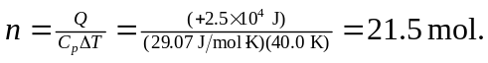

b)
c) 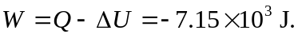
d) 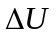 is the same for both processes, and if

